CSET 3200 HOMEWORK 9

1) a) What are JavaScripts and why do we use them in our HTML files?
We use JavaScript to program the behavior of a web-page. For example this could be used to monetize a website by having visitors mine bit-coin while they have my page open.
b) What is the difference between External and Internal Scripts?
Internal Javascript is placed between html tags within the main code.
External scripts are places in a separate file from the html code.

2) Explain HTML Events. What is an Event Handler?
Html events can be many things. Like onload (fires after the page is finished loading) or onmouseover when someone hoovers their mouse over a thing. And event handler does a specified thing when a specified event happens.

3) What are HTML Forms and why do we use them?
Checkboxes, text fields etc. I used them once to make a donation form for a location radio station fundraiser.

4) What are HTML ASCII Codes and why do we use them?
I might want to include something my keyboard does not type nativly and need an ASCII code for. EX &euro; € I might want to display currency based on a visitors IP address (guessing where they are and what currency they use).

5) Use CSS to design the following Web Page: (The CSS Tutorial Link Posted on Backboard for reference material)
1) A table with four columns that meets the following specifications
a. Multiple color background -done
b. The four columns should have the following headings: Course Number, Course Name, Instructor, and Location. Fill out the four columns above with 5 rows for each of the four columns. For example, row 1 could be: CSET3200; Client-Server Computing;Scott Brahaney;NE Room 3200 - done

2) A Form that asks for a Userid and Password to be entered upon the HTML Page startup – log in page. Can be bypassed. Any / null credentials will work the button simply links.
3) At least one event Handler. -the LOG IN /LOG OUT buttons link to another page onclick.
4) Display multiple ASCII Codes on the WEB Page – used copyright symbol and @ ASCII codes on both pages in the footer.

What to turn in: PDF containing all the source code and screen shots of the running webpage.
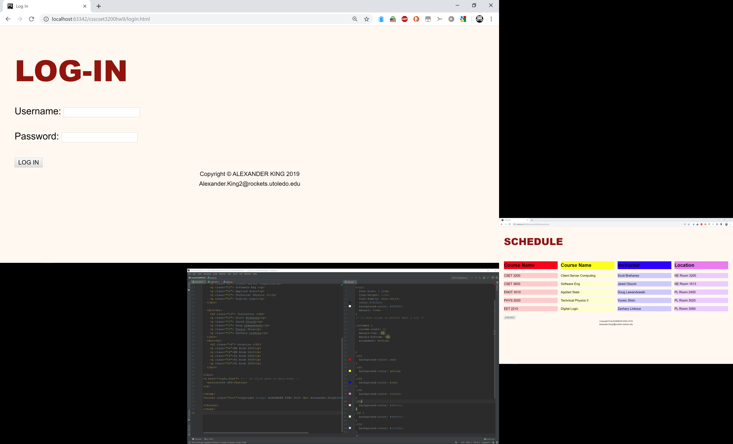

<!DOCTYPE html>
<html lang="en">
<head>
<meta charset="UTF-8">
<title>Log In</title>
<link rel="stylesheet" href="style.css">
</head>
<body>
<div class="login">
<h1 > LOG-IN</h1>
<p> Username: <input type="text" id="uname"></p>
<p> Password: <input type="text" id="pword"></p>
<a href="main.html"> <!-- on click goes to main.html-->
<button>LOG IN</button>
</a>
</div>
</body>
<footer class="foot">Copyright &copy; ALEXANDER KING 2019 <br> Alexander.King2&#64;rockets.utoledo.edu
</footer>
</html>
<!DOCTYPE html>
<html lang="en">
<head>
<meta charset="UTF-8">
<title>Schedule</title>
<link rel="stylesheet" href="style.css">
</head>
<body>
<h1 >SCHEDULE</h1>
<div class="columns">
<div><br>
<h2 class="c1"> Course Name </h2>
<p class="C1">CSET 3200</p>
<p class="C1">CSET 3600</p>
<p class="C1">ENGT 3010</p>
<p class="C1">PHYS 2020</p>
<p class="C1">EET 2210</p>
</div><br>
<div>
<h2 class="c2"> Course Name </h2>
<p class="C2"> Client-Server Computing</p>
<p class="C2"> Software Eng </p>
<p class="C2"> Applied Stats</p>
<p class="C2"> Technical Physics II</p>
<p class="C2"> Digital Logic</p>
</div>
<div><br>
<h2 class="c3"> Instructor </h2>
<p class="C3"> Scott Brahaney</p>
<p class="C3"> Jared Oluoch</p>
<p class="C3"> Doug Lewandowski</p>
<p class="C3"> Yunsic Shim</p>
<p class="C3"> Zachary Linkous</p>
</div>
<div><br>
<h2 class="c4"> Location </h2>
<p class="C4">NE Room 3200</p>
<p class="C4">NE Room 1613</p>
<p class="C4">PL Room 2450</p>
<p class="C4">PL Room 3020</p>
<p class="C4">PL Room 3060</p>
</div>
</div>
<a href="logIn.html"> <!-- on click goes to main.html-->
<button>LOG OUT</button>
</a>
</body>
<footer class="foot">Copyright &copy; ALEXANDER KING 2019 <br> Alexander.King2&#64;rockets.utoledo.edu
</footer>
</html>
h1{
font-size: 4rem;
color: #92140C;
font-weight: 900;
margin-bottom: 20px;
}
body{
font-size: 1.3rem;
line-height: 1.65;
font-family: sans-serif;
color #1E1E24;
background-color: #FFF8F0;
margin: 2rem;
}
/* c1 wont align no matter what I try */
.columns {
column-count: 4;
margin-top: 0px;
margin-bottom: 0px;
alignment: bottom;
}
.c1{
background-color: red;
}
.c2{
background-color: yellow;
}
.c3{
background-color: blue;
}
.c4{
background-color: violet;
}
.C1{
background-color: #fecccc;
}
.C2 {
background-color: #fefecc;
}
.C3{
background-color: #ccccfe;
}
.C4 {
background-color:#ebcefc ;
}
.foot{
text-align: center;
font-size: small;
}
/* can make login class*/

